**Name :** _ **Roll No.** _ **Page No***._*

**Week-12 Prelab-12 : IIoT 1.What is IIoT**

IIoT stands for Industrial Internet of Things. It refers to the use of interconnected sensors, instruments, and other devices in industrial applications to collect, exchange, and analyze data, leading to improved efficiency, productivity, and decision-making.

1. **What is industry 4.0?**

Industry 4.0, also known as the fourth industrial revolution, encompasses the integration of digital technologies into industrial processes. It includes concepts like automation, data exchange, artificial intelligence, and smart manufacturing.

1. **What is the difference between Industry 4.0 and the Internet of Things?**

**Industry 4.0:**

* Focuses specifically on industrial processes and manufacturing.
* Involves integrating digital technologies like automation, data exchange, and artificial intelligence into industrial operations.
* Aims to improve efficiency, productivity, and decision-making in manufacturing and related industries.

**Internet of Things (IoT):**

* Encompasses a broader range of interconnected devices, objects, and systems beyond industry.
* Includes various applications such as consumer electronics, smart homes, healthcare devices, transportation systems, and more.
* Focuses on connecting devices to the internet to enable data collection, communication, and interaction.

**4. What is the difference between Industry 4.0 and the IIoT ?**

**Industry 4.0:**

* Focuses on the overall integration of digital technologies into industrial processes and manufacturing.
* Encompasses concepts like automation, data exchange, artificial intelligence, and smart manufacturing.
* Aims to optimize efficiency, productivity, and decision-making in manufacturing and related industries.
* Involves the transformation of traditional factories into smart factories through the use of advanced technologies.
* Emphasizes the convergence of physical and digital systems in industrial settings.

**IIoT (Industrial Internet of Things):**

* Specifically focuses on the use of interconnected sensors, instruments, and devices in industrial applications.
* Involves collecting, exchanging, and analyzing data to improve operational efficiency, predict

maintenance needs, and enhance decision-making.

•

•

Enables remote monitoring and control of industrial equipment and processes.

Often involves retrofitting existing industrial infrastructure with IoT devices or integrating IoT

capabilities into new equipment.

* Aims to enhance asset management, reduce downtime, and optimize resource utilization in

industrial environments.

**Week-11**

**Prelab-11 : Upload the weather information on the open-source cloud**

**“ThingSpeak”**

1. **Write the steps to create a user account in thingspeak cloud.**
   1. **Visit ThingSpeak Website:** Go to the ThingSpeak website (thingspeak.com).
   2. **Sign Up:** Click on the "Sign Up" button.
   3. **Fill Registration Form:** Enter your email address, desired username, and password.
   4. **Verify Email:** Check your email for a verification message from ThingSpeak and follow the instructions to verify your email address.
   5. **Login:** Once verified, log in to your new ThingSpeak account using your credentials.
   6. **Complete Profile:** Optionally, complete your profile information if required.
   7. **Start Using ThingSpeak:** You're now ready to start using ThingSpeak to create IoT applications, visualize data, and analyze sensor data.

**2.What is the purpose of WRITE API key.**

WRITE API keys enable authorized users to:

•

•

•

•

Submit data to a platform programmatically (Data Submission).

Integrate with third-party applications for seamless data exchange (Integration).

Ensure authorized access for writing data, enhancing security (Authorization). Automate data submission processes for efficiency (Automation).

**3.What is the purpose of READ API key.**

READ API keys allow:

•

•

•

Accessing and retrieving data from a service programmatically (Data Retrieval).

Integrating with third-party applications for analysis or visualization (Integration).

Ensuring authorized access to retrieve data, enhancing security (Authorization).

**Name :** _ **Roll No.** _ **Page No**.

* Automating data retrieval processes for seamless integration (Automation).

1. **What is a channel in ThingSpeak Cloud.**

In ThingSpeak, a channel is like a digital notebook where you can store data from your sensors or devices.

* + **Data Storage**: It's a virtual storage unit where data from sensors or devices is collected and stored.
  + **Fields:** Channels have different sections to organize various types of data, such as temperature, humidity, or any other measurements.
  + **Metadata:** Each channel has a name, description, and settings for data visualization and access control.
  + **API Access**: ThingSpeak provides APIs to interact with channels programmatically, enabling reading and writing data.
  + **Visualizations**: Built-in tools allow users to create charts, graphs, and gauges to visualize data stored in channels.
  + **Access Control:** Channels can be set to public or private, controlling who can view the data stored in them.
  + **Data Logging**: Channels continuously log incoming data points along with timestamps for historical analysis.

1. **Write the applications of Cloud Computing.**
   * Infrastructure Services (IaaS): Provisioning virtual servers, storage, and networking resources.
   * Platform Services (PaaS): Developing and deploying applications without managing underlying infrastructure.
   * Software Services (SaaS): Accessing software applications over the internet.

**Name :** _ **Roll No.** _ **Page No**.

•

•

•

•

•

•

•

Big Data Analytics: Processing and analyzing large datasets.

Internet of Things (IoT): Collecting, storing, and analyzing data from IoT devices.

Data Storage and Backup: Storing and backing up data securely in the cloud. Content Delivery and Media Streaming: Delivering multimedia content globally. E-commerce: Hosting e-commerce websites and managing online transactions. Collaboration Tools: Hosting communication and collaboration platforms.

Gaming: Hosting online gaming platforms and multiplayer games.

**Name :** _ **Roll No.** _ **Page No**.

**Lab Program:**

**1.Write a Program to upload the weather information on to the open-source cloud “ThingSpeak”. Sourcecode:**

import sys

import time

sys.path.append(‘/home/pi/ETS_IoT KIT demo/DemoCode/BME280’) import BME280lib as bme

import urllib.request as ur while True:

t,p,h=bme.readBME280All( ) print(‘Temperature :’,t)

print(‘Pressure:’,p) print(‘Humidity :’,h)

st=’https:// api.thingspeak.com/update?api_key=FBMA7CJW92DJJ1S&field1=’+ str(t)+ ’&field2=’+str(p)+’&field3=’+str(h)

f=ur.urlopen(st) time.sleep(2)

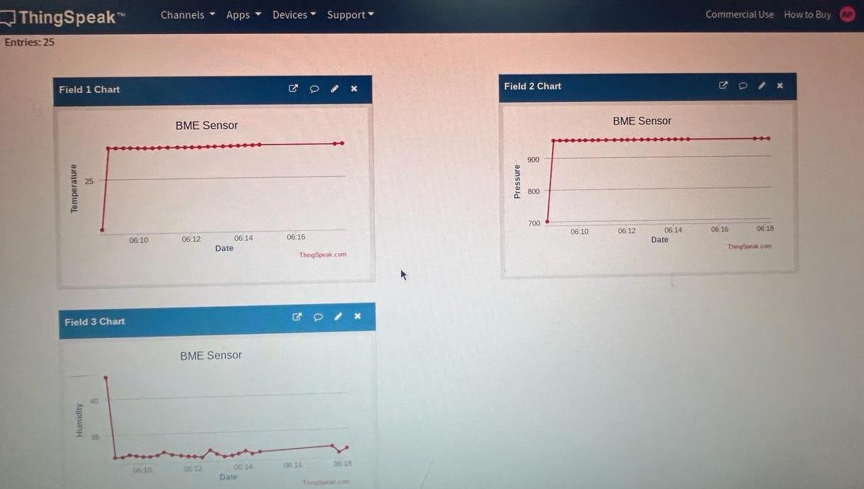

**Name :** _ **Roll No.** _ **Page No**._

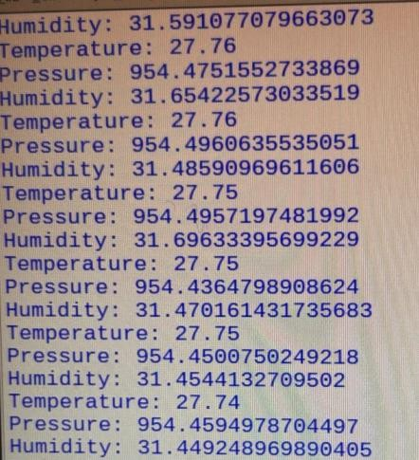

Output:

**Name :** _ **Roll No.** _ **Page No**.

**Week-10**

**Prelab-10 : LoRa**

1. **What is LoRa?**

LoRa stands for Long Range, a wireless communication technology developed for long-range, low- power communication between devices in the Internet of Things (IoT) applications.

1. **What is the difference between LoRa and LoRaWAN.**

LoRa is the physical layer technology, while LoRaWAN is the networking protocol built on top of LoRa, enabling long-range communication between IoT devices and a central network server.

1. **What are the advantages of LoRaWAN.**

Advantages of LoRaWAN include its long-range capability (up to several kilometers), low power consumption, scalability, and support for large numbers of devices in a single network.

1. **What are the LoRaWAN frequencies used in INDIA and USA?**

In India, LoRaWAN operates in the 865-867 MHz frequency band, while in the USA, it operates in the 902-928 MHz frequency band, adhering to local regulations.

1. **What is LoRaWAN gateway?**

A LoRaWAN gateway is a device that receives communication from LoRa-enabled devices and forwards it to a central network server, typically using the Internet. It acts as a bridge between the devices and the network server, enabling communication over long distances.

**Week-10**

**Lab Programs**

**Lora_Node1_sending_data_to_gateway**

#include <dht11.h> #include <SPI.h>

#include <LoRa.h>

int P = 6; //Powersensor - 6 int R = 5; //Reed Switch - 5 int X = 7; //PIR sensor - 7

int T = A2; // TEMPERATURE - A2 has already been defined as Analog Pin 2 in arduino lib int H = A5; //HUMIDITY

int L = A4; //LIGHT

float CELSIUS, HUM, LIGHT;

String data, DOOR, MOT, POW; dht11 DHT11;

#define Lora_kit 001

#define Lora_Node 001

void setup()

{

pinMode(P, INPUT); pinMode(R, INPUT); pinMode(X, INPUT); Serial.begin(9600);

Serial.println("-------Lora Kit ");

if (!LoRa.begin(433E6))

{

Serial.println("Starting LoRa failed!");

Serial.println("Please check the Lora Connections"); while (1);

}

LoRa.setSyncWord(0xA1); // The sync word assures you don't get LoRa messages from other LoRa transceivers

}

void TEMPERATURE()

{

int value_temp = analogRead(T); //Read analog value of temperature sensor output from pin A2 delay(10);

value_temp = analogRead(T); delay(10);

float millivolts_temp = (value_temp / 1023.0) * 5000; //convert it to milli volts output ([actual temperature output from sensor] * [Input voltage (5V = 5000mV)] / [Resolution of ADC 2^10 = 1024])

CELSIUS = millivolts_temp / 10; Serial.print("Temperature : "); Serial.println(CELSIUS);

}

void HUMIDITY()

{

int chk = DHT11.read(H); HUM = DHT11.humidity; Serial.print("Humidity : "); Serial.println(HUM);

}

void LIG()

{

int value_lig = analogRead(L); delay(10);

value_lig = analogRead(L);

float volts_lig = (value_lig / 1023.0) * 5;

LIGHT = 500/(4*((5-volts_lig)/volts_lig)); // calculate the Lux = 500/[R1 * ((Vin - Vsense)/Vsense)] Serial.print("Light : ");

Serial.print(LIGHT); Serial.println(" Lux");

}

void POWER()

{

if (digitalRead(P) == LOW) // if output form sensor is '0' then print NO power

{

POW = "OFF";

Serial.print("Power : "); Serial.println(POW);

}

else

{

POW = "ON";

Serial.print("Power : "); Serial.println(POW)

}

}

Void REED()

{

if (digitalRead(R) == LOW)

{

DOOR = "OPEN";

Serial.print("Reed/Door : "); Serial.println(DOOR);

}

else

{

DOOR = "CLOSE";

Serial.print("Reed/Door : "); Serial.println(DOOR);

}

}

void PIR()

{

if (digitalRead(X) == LOW)

{

MOT = "YES";

Serial.print("PIR : "); Serial.println(MOT);

}

else

{

MOT = "NO";

Serial.print("PIR : "); Serial.println(MOT);

}

Serial.println();

}

void loop()

{

TEMPERATURE(); HUMIDITY(); LIG();

REED();

POWER();

PIR();

delay(500); LoRa.beginPacket(); LoRa.print("Lora kit: "); LoRa.print(Lora_kit); LoRa.print(" Lora Node: "); LoRa.println(Lora_Node); LoRa.print("Temperature: "); LoRa.println(CELSIUS);

LoRa.print("Humidity: "); LoRa.println(HUM); LoRa.print("Light: "); LoRa.println(LIGHT); LoRa.print("POWER: "); LoRa.println(POW); LoRa.print("DOOR: "); LoRa.println(DOOR); LoRa.print("PIR: "); LoRa.println(MOT); LoRa.endPacket(); delay(5000);

}

**LoRa_Node2_sending_data_to_gateway**

#include <dht11.h> #include <SPI.h> #include <LoRa.h>

int P = 6; //Powersensor - 6 int R = 5; //Reed Switch - 5 int X = 7; //PIR sensor - 7

int T = A2; // TEMPERATURE - A2 has already been defined as Analog Pin 2 in arduino lib int H = A5; //HUMIDITY

int L = A4; //LIGHT

float CELSIUS, HUM, LIGHT;

String data, DOOR, MOT, POW; dht11 DHT11;

#define Lora_kit 001 // Enter Your Lora kit #define Lora_Node 002 // Enter Your Lora Node

void setup()

{

pinMode(P, INPUT); pinMode(R, INPUT); pinMode(X, INPUT); Serial.begin(9600);

Serial.println("-------Lora Kit ");

if (!LoRa.begin(433E6))

{

Serial.println("Starting LoRa failed!"); Serial.println("Please check the Lora Connections"); while (1);

}

LoRa.setSyncWord(0xA1); // The sync word assures you don't get LoRa messages from other LoRa transceivers

}

void TEMPERATURE()

{

int value_temp = analogRead(T); //Read analog value of temperature sensor output from pin A2 delay(10);

value_temp = analogRead(T); delay(10);

float millivolts_temp = (value_temp / 1023.0) * 5000; //convert it to milli volts output ([actual temperature output from sensor] * [Input voltage (5V = 5000mV)] / [Resolution of ADC 2^10 = 1024])

CELSIUS = millivolts_temp / 10; Serial.print("Temperature : "); Serial.println(CELSIUS);

}

void HUMIDITY()

{

int chk = DHT11.read(H); HUM = DHT11.humidity; Serial.print("Humidity : "); Serial.println(HUM);

}

void LIG()

{

int value_lig = analogRead(L); delay(10);

value_lig = analogRead(L);

float volts_lig = (value_lig / 1023.0) * 5;

LIGHT = 500/(4*((5-volts_lig)/volts_lig)); // calculate the Lux = 500/[R1 * ((Vin - Vsense)/Vsense)] Serial.print("Light : ");

Serial.print(LIGHT); Serial.println(" Lux");

}

void POWER()

{

if (digitalRead(P) == LOW) // if output form sensor is '0' then print NO power

{

POW = "OFF";

Serial.print("Power : "); Serial.println(POW);

}

else

{

POW = "ON";

Serial.print("Power : "); Serial.println(POW);

}

}

void REED()

{

if (digitalRead(R) == LOW)

{

DOOR = "OPEN";

Serial.print("Reed/Door : "); Serial.println(DOOR);

}

else

{

DOOR = "CLOSE";

Serial.print("Reed/Door : "); Serial.println(DOOR);

}

}

void PIR()

{

if (digitalRead(X) == LOW)

{

MOT = "YES";

Serial.print("PIR : "); Serial.println(MOT);

}

else

{

MOT = "NO";

Serial.print("PIR : "); Serial.println(MOT);

}

Serial.println();

}

void loop()

{

TEMPERATURE(); HUMIDITY();

LIG();

REED();

POWER();

PIR();

delay(500); LoRa.beginPacket(); LoRa.print("Lora kit: "); LoRa.print(Lora_kit); LoRa.print(" Lora Node: "); LoRa.println(Lora_Node); LoRa.print("Temperature: "); LoRa.println(CELSIUS); LoRa.print("Humidity: "); LoRa.println(HUM); LoRa.print("Light: "); LoRa.println(LIGHT); LoRa.print("POWER: "); LoRa.println(POW); LoRa.print("DOOR: "); LoRa.println(DOOR); LoRa.print("PIR: "); LoRa.println(MOT); LoRa.endPacket(); delay(5000);

}

**LoRa_Node3_sending_data_to_gateway**

#include <dht11.h> #include <SPI.h> #include <LoRa.h>

int P = 6; //Powersensor - 6 int R = 5; //Reed Switch - 5 int X = 7; //PIR sensor - 7

int T = A2; // TEMPERATURE - A2 has already been defined as Analog Pin 2 in arduino lib int H = A5; //HUMIDITY

int L = A4; //LIGHT

float CELSIUS, HUM, LIGHT;

String data, DOOR, MOT, POW; dht11 DHT11;

#define Lora_kit 001

#define Lora_Node 003

void setup()

{

pinMode(P, INPUT); pinMode(R, INPUT); pinMode(X, INPUT); Serial.begin(9600);

Serial.println("-------Lora Kit ");

if (!LoRa.begin(433E6))

{

Serial.println("Starting LoRa failed!"); Serial.println("Please check the Lora Connections"); while (1);

}

LoRa.setSyncWord(0xA1); // The sync word assures you don't get LoRa messages from other LoRa transceivers

}

void TEMPERATURE()

{

int value_temp = analogRead(T); //Read analog value of temperature sensor output from pin A2 delay(10);

value_temp = analogRead(T); delay(10);

float millivolts_temp = (value_temp / 1023.0) * 5000; //convert it to milli volts output ([actual temperature output from sensor] * [Input voltage (5V = 5000mV)] / [Resolution of ADC 2^10 = 1024])

CELSIUS = millivolts_temp / 10; Serial.print("Temperature : "); Serial.println(CELSIUS);

}

void HUMIDITY()

{

int chk = DHT11.read(H); HUM = DHT11.humidity; Serial.print("Humidity : "); Serial.println(HUM);

}

void LIG()

{

int value_lig = analogRead(L); delay(10);

value_lig = analogRead(L);

float volts_lig = (value_lig / 1023.0) * 5;

LIGHT = 500/(4*((5-volts_lig)/volts_lig)); // calculate the Lux = 500/[R1 * ((Vin - Vsense)/Vsense)] Serial.print("Light : ");

Serial.print(LIGHT); Serial.println(" Lux");

}

void POWER()

{

if (digitalRead(P) == LOW) // if output form sensor is '0' then print NO power

{

POW = "OFF";

Serial.print("Power : "); Serial.println(POW);

}

else

{

POW = "ON";

Serial.print("Power : "); Serial.println(POW);

}

}

void REED()

{

if (digitalRead(R) == LOW)

{

DOOR = "OPEN";

Serial.print("Reed/Door : "); Serial.println(DOOR);

}

else

{

DOOR = "CLOSE";

Serial.print("Reed/Door : "); Serial.println(DOOR);

}

}

void PIR()

{

if (digitalRead(X) == LOW)

{

MOT = "YES";

Serial.print("PIR : "); Serial.println(MOT);

}

else

{

MOT = "NO";

Serial.print("PIR : "); Serial.println(MOT);

}

Serial.println();

}

void loop()

{

TEMPERATURE(); HUMIDITY(); LIG();

REED();

POWER();

PIR();

delay(500); LoRa.beginPacket(); LoRa.print("Lora kit: "); LoRa.print(Lora_kit); LoRa.print(" Lora Node: "); LoRa.println(Lora_Node); LoRa.print("Temperature: "); LoRa.println(CELSIUS); LoRa.print("Humidity: "); LoRa.println(HUM); LoRa.print("Light: "); LoRa.println(LIGHT); LoRa.print("POWER: "); LoRa.println(POW); LoRa.print("DOOR: "); LoRa.println(DOOR); LoRa.print("PIR: "); LoRa.println(MOT); LoRa.endPacket(); delay(5000);

}

**Receiving_the_data_from_LoRa_nodes**

#include <SPI.h> #include <LoRa.h>

#define ss 15

#define rst 16

#define dio0 2

void setup()

{

Serial.begin(115200);

Serial.println("-------Lora Gateway ");

LoRa.setPins(ss, rst, dio0); if (!LoRa.begin(433E6))

{

Serial.println("Starting LoRa failed!"); Serial.println("Please check the Lora Connections"); while (1);

}

LoRa.setSyncWord(0xA1); // The sync word assures you don't get LoRa messages from other LoRa transceivers

}

void loop()

{

int packetSize = LoRa.parsePacket(); if (packetSize)

{

// read packet

while (LoRa.available())

{

Serial.print((char)LoRa.read());

}

Serial.print("Signal Strength: "); Serial.println(LoRa.packetRssi()); Serial.println();

Serial.println(); Serial.println();

}

}

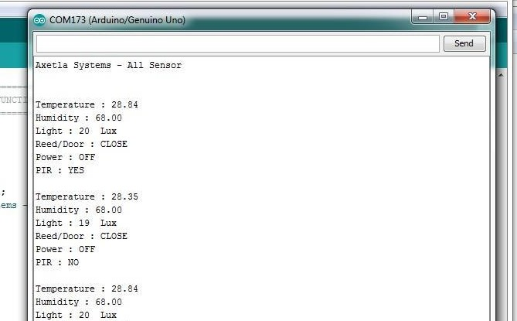

**Output:**

**Week-09**

**Prelab-09 : MQTT**

1. **Mention applications or use cases of MQTT protocol.**

MQTT protocol finds applications in various fields such as IoT (Internet of Things) communication, real-time messaging, remote monitoring and control systems, telemetry, and more.

1. **What is MQTT topic?**

An MQTT topic is a string that the MQTT broker uses to filter messages for each connected client. It acts as a "channel" through which messages are published and subscribed to.

1. **Explain MQTT broker architecture with one use case example.**

In MQTT broker architecture, clients communicate with each other through a central broker. For example, in a smart home system, sensors (clients) publish temperature data to the broker, and devices like thermostats (other clients) subscribe to receive that data from specific topics on the broker.

1. **What is the difference between MQTT and HTTP?**

MQTT is a lightweight messaging protocol designed for efficient communication between devices with low bandwidth and unreliable networks, often used in IoT scenarios. HTTP, on the other hand, is a traditional request-response protocol commonly used for web communication. MQTT is more lightweight, making it suitable for constrained environments, while HTTP is more feature-rich and widely used for web applications.

1. **Which port is used in MQTT protocol?**

MQTT typically uses port 1883 for non-secure communication and port 8883 for secure communication (TLS/SSL).

**Week-9**

**Lab Programs: MQTT MQTT Subscriber**

import paho.mqtt.client as mqtt

def on_connect(client, userdata, flags, rc):

print(“Connected with MQTT Server “+str(rc)) client.subscribe(“iot/home”)

def on_message(client, userdata, msg):

print(msg.topic+“ ”+str(msg.payload))

client = mqtt.Client() client.on_connect = on_connect client.on_message = on_message

client.connect(“test.mosquitto.org”, 1883,60)

client.loop_forever()

**MQTT Publisher**

import paho.mqtt.client as mqtt

publish.single(“iot/home”, “temperature”, hostname=”test.mosquitto.org”) print(“Done”)

**Week-08**

**Prelab-08 : ZIGBEE**

1. **What is Zigbee?**

Zigbee is a low-power, low-data-rate wireless communication protocol commonly used in IoT (Internet of Things) applications for short-range wireless connectivity.

1. **Write the characteristics of a zigbee network.**

Characteristics of a Zigbee network include low power consumption, low data rate, mesh networking capability, support for multiple network topologies (star, mesh, and cluster tree), and suitability for battery-operated devices.

1. **Give the frequency in MHz of the highest band used by the zigbee technology**

The highest band used by Zigbee technology operates at a frequency of 2.4 GHz.

1. **What are network coordinator and end-device in zigbee technology?**

In Zigbee technology, the network coordinator is responsible for forming and managing the network, while end-devices are typically the sensors or actuators that communicate with the coordinator or other devices within the network.

1. **What is the typical range of transmission distance in a zigbee network?**

The typical range of transmission distance in a Zigbee network varies depending on factors such as the environment and the specific Zigbee devices used, but it can range from a few meters to several hundred meters.

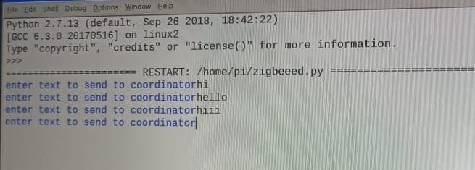

**Week-8**

**Lab Programs:**

**1.ZIGBEE end device. Sourcecode:**

import time import serial

ser=serial.Serial(port=’/dev/ttyUSB0’,baudrate=9600, parity=serial.PARITY_NONE, stopbits=serial.STOPBITS_ONE, bytesize=serial.EIGHTBITS,timeout=1)

while True:

x=raw_input(‘enter text to send to coordinator’)

ser.write(x) time.sleep(1)

**Output:**



1. **ZIGBEE router device. Sourcecode:**

import time import serial

ser=serial.Serial(port=’/dev/ttyUSB0’,baudrate=9600, parity=serial.PARITY_NONE,

stopbits=serial.STOPBITS_ONE,bytesize=serial.EIGHTBITS,timeout=1) while True:

x=’blank’

x=ser.readline()

print ‘message from EN: %s’ %X ser.write(‘message from R: %s’ %X) time.sleep(1)

1. **ZIGBEE Coordinator device. Sourcecode:**

import time import serial

ser=serial.Serial(port=’/dev/ttyUSB0’,baudrate=9600, parity=serial.PARITY_NONE,

stopbits=serial.STOPBITS_ONE,bytesize=serial.EIGHTBITS,timeout=1) while 1:

msg=s.readline() print(msg)

**Output:**